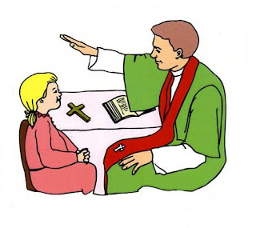
First Reconciliation/First Eucharist Application
Fee: $30.00
(Give parent a copy of this application)
Please Print

Name of child (Full Name)

_

Birth Date: Place:

Parents

Father’s Name:

Mother’s Name: Maiden name: _

Address: _______________________________________________________________________________

Phone: _ Email:

Office use: BAPTISM VERIFICATION _ DATE: __ If not in this parish we need a copy of the baptismal certificate:
_ __

Our family will participate in the First Reconciliation & First Eucharist Program by: Attending retreats and parent classes.
Godparents: _________________________________________________________

_ Date:___________
Signature of parent

- First Communion Attire: Dress for girls:
- A white dress or a white blouse with a white skirt; a white veil is optional. Dress or skirt should be to the knee and no shoulders exposed. A sweater or jacket may be worn to cover shoulders.
- white, black, grey, navy blue, tan, taupe, or brown shoes; no sneakers
- only simple jewelry, if any--nothing large or with wildly bright colors
- Dress for boys :
- sports jacket: navy blue, black, dark brown, dark grey, or white; optional
- tie suitable for the solemnity of the sacrament.
- slacks that sit at the waist: a solid color that matches or blends with the jacket; no jeans
- white, black, grey, navy blue, tan, taupe, or brown shoes; no sneakers

